**FallingLetters with Unity (C#), FastAPI (Python) and Firebase.**

**Unity Folder Structure**

(Only the most necessary folders to understand the game are discussed here.)

1. **Audio** – Contains all the audio files required by the game.
2. **Prefab** - Contains special type of components that allows fully configured GameObjects to be saved in the Project for reuse. These can be called during run time.
3. **Scenes** – Contains all the 7 scenes of the game. They are containers that holds all parts of the GUI of the game.
4. **Scripts** – This is where the C# source codes are stored. (MVC).

**Scenes**

Scenes are assets that act as containers for all or part of a game or application, allowing you to organize and manage your game's content, such as levels, menus, and environments. There are 7 such scenes in the game. Those are,

View folder of the MVC architecture is further divided into scenes.

1. **Login Scene**
2. **MainMenu Scene**
3. **MainGame Scene**
4. **ExtraAttempts Scene**
5. **LeadeBoard Scene**
6. **InternetChecker Scene**
7. **GameOver Scene.**

The whole GUI of the game is managed by these Unity Scenes. They are stored in the **Assets > Scenes** folder.

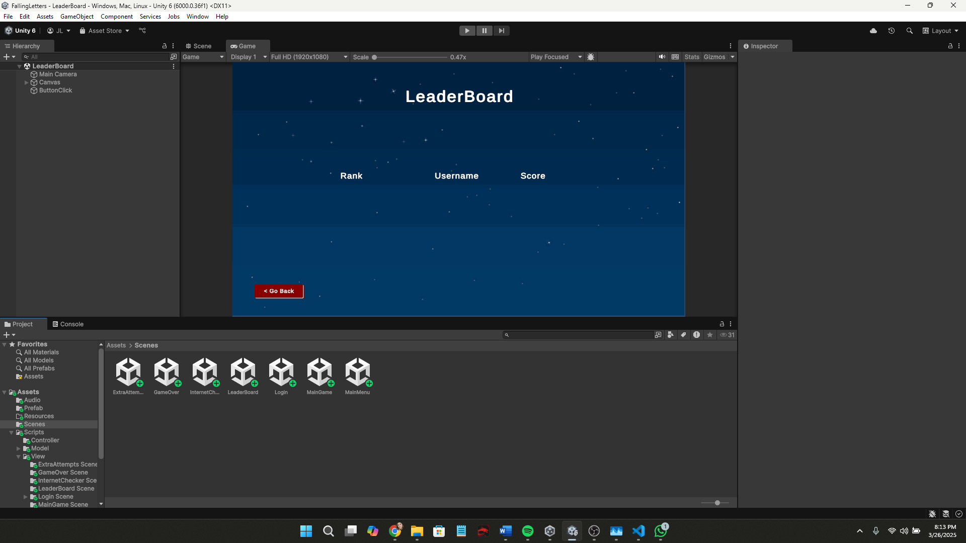

We can attach MonoBehaviour C# scripts into the GUI components within these scenes and to the components in the Prefab folder. (MonoBehaviour is a class that every C# script should inherit to directly perform GUI functions or to directly communicate with the GUI.)

1. **Login Scene**

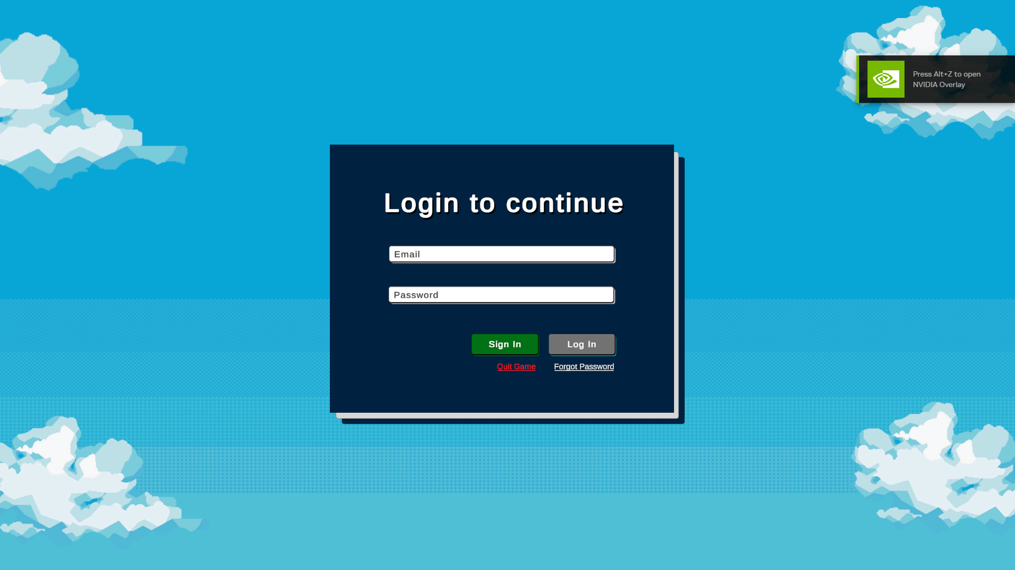

Main interface of the Login Scene. Out of all the scripts under the Login Scene folder in MVC model. This main interface contains,

1. HandleLogin.cs
2. HandleLoginValidate.cs